Xbox Central Upload/Download site.

System Requirements:
IE5 or better
Win2000/SP2 or Win98 (WebDrive will only work with Win2000)

IE Configuration:
In IE, go to Tools-Internet Options-Security. Click on Custom Level. Enable launching programs and files in an IFRAME.

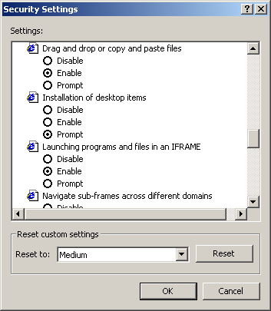

Now go to https://xds.xbox.com (Note the https)
Enter your user name and password (CASE SENSITIVE) at this screen. This can be a “copy and paste” from your email.

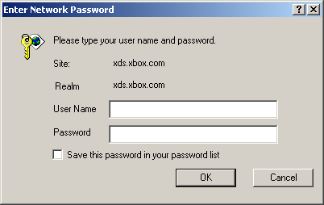

File Transfer Page. Click on “Transfer” on the navigation image and then click on appropriate upload page link on left (Yours will not say PublicDrop)
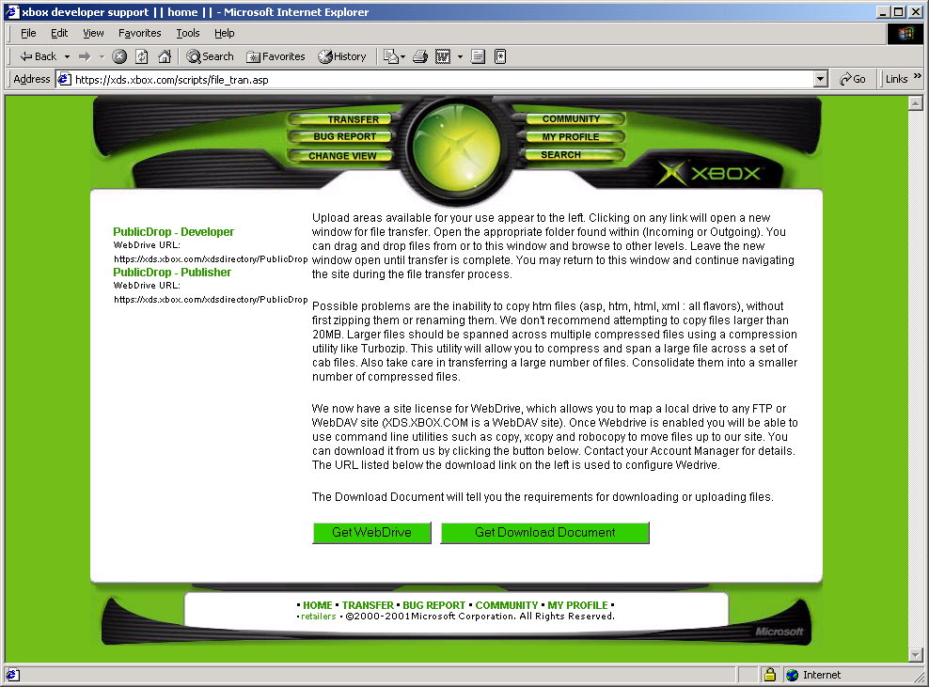

You will then see a window similar to this. You can drag and drop to and from this window. You can also browse within the directory structure, view file properties and cut and paste.

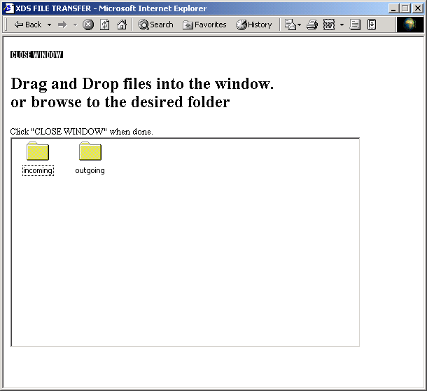

Possible problems are the inability to copy htm files (asp, htm, html, xml : all flavors), without first zipping them or renaming them. We don't recommend attempting to copy files larger than 20MB. Larger files (or a large group of individual files) should be spanned across multiple compressed files using a compression utility like Turbozip. This utility will allow you to compress and span a large file (or a large group of individual files) across a set of cab files.
We now have a site license for WebDrive, which allows you to map a local drive to any FTP or WebDAV site (XDS.XBOX.COM is a WebDAV site) if you are using Win2000. Once Webdrive is enabled you will be able to use command line utilities such as copy, xcopy and robocopy to move files up to our site. Robocopy supports Network Restartable, which will allow you to begin and complete your upload unattended. You can download it from us by clicking the WebDrive. See the WebDrive section at the end of this document for details.

WebDrive Configuration

After installing WebDrive, open the Site Manager and configure a new site. Use the following settings:

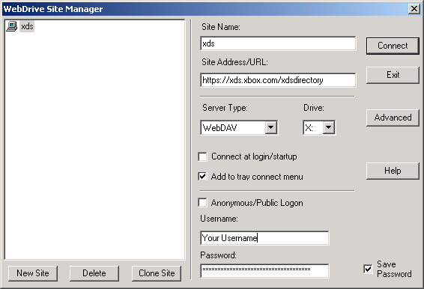

The Username and password will be your login information. The drive letter can be set to any letter.

Note: You will need to contact your Account Manager for specifics on which Site Address/URL to use. The format will follow https://xds.xbox.com/xdsdirectory/[TITLE] where TITLE is the game title you are working. You can find this URL on the file transfer page under the navigation link for your site. In the example for this document, the Site Address/URL would be https://xds.xbox.com/xdsdirectory/PublicDrop .

